FIN3080 Assignment 1

1. 根据CSMAR数据，我做出了如下图表：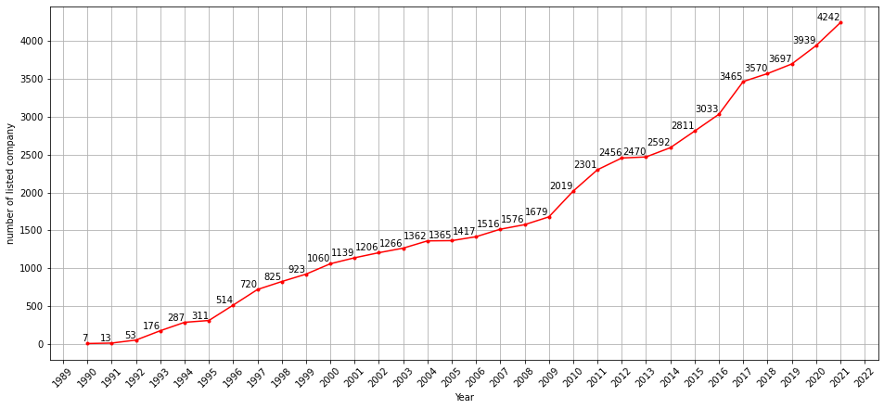

说明：

1. 本图所用数据来自CSMAR数据库，路径为首页-数据中心-单表查询-股票市场系列-股票市场交易-各分市场交易数据-年市场回报率文件

通过回报率文件可得到当年在股票市场上存在交易的上市公司数量。

1. 原数据含三列，

Markettype [市场类型] - 1=上证A股市场 (不包含科创板），2=上证B股市场，4=深证A股市场（不包含创业板），8=深证B股市场，16=创业板， 32=科创板，64=北证A股市场。Trdynt [交易年份] - 以YYYY表示。

Ynstkcal [计算年市场回报率的有效公司数量] - 上年和今年皆有有效交易的公司。

我使用市场类型进行选择（1，4，16）后根据年份进行归类求和得到每年累积的上市公司数量，并使用matplotlib进行图表的建立。代码文件Q1_120090651.py。

2. The Difference between DCF and Relative Pricing

DCF:

1. Required Inputs：Future Cash Flow, Growth Rate of the cash flow, The required rate of return(Discount Rate)
2. Advantages：
   1. We can justify the intrinsic value of an equity
   2. Different variations of the model account for different growth rates, that is, we can use multistage models to make our model more precise.
3. Disadvantages:
   1. Here are a lot of assumptions to be made, so there may be a huge bias due to the assumptions that you have made
   2. It is quite difficult to forecast the precise future cash flow for a company

Relative Pricing:

1. Required Inputs: Ratios from a similar company in the same industry, The Financial Metric of the to-be-valued firm.
2. Advantages:
   1. Easy to understand and apply
   2. There’re fewer assumptions needed than with the DCF
   3. By using this model, we can better know about the condition of the current market
3. Disadvantages:
   1. Different comparable choices may lead to a bias
   2. Sometimes it’s difficult to find a comparable company (e.g. Google)

In conclusion, we need to determine which model to use by the inputs. When we have the certainty that we have precise future cash flow and discount rate and growth rate, we often choose DCF to get the result. However, if we don’t have much information about the above stats, we often choose a similar company to use the Relative Pricing to get the data that we want.